Project Architecture Document

# Architecture Overview

A good architecture can cover most of the non functional requirements. Designing it was the most crucial task of this phase. We have finalized a monolithic design for our application where the back-end application consists of REST APIs with proper authorization and the front-end service will make requests to these APIs.

The finalized technology stack for the project is given below:

* Back-end service: Java (Spring Boot)
* Front-end service: Angular 9
* Database: MySQL
* IDE: Eclipse, IntelliJ Idea, Visual Studio Code
* Database Client: MySQL Workbench
* Other Tools: Postman, SourceTree, Github

# 

# UML Diagrams

## Use-Case Diagram:

## 

## Entity Relationship Diagram:

## 

## 

## Class Diagram:

## 

## 

## Sequence Diagram:

### Tutor:

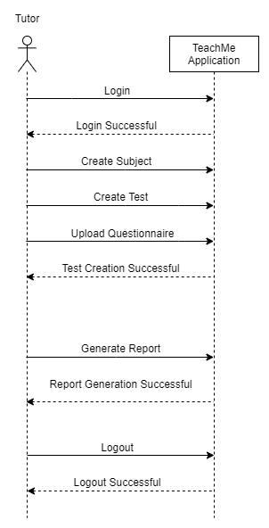

### Student:

